Direct Simulation with a Proportional Effect: the Lognormal Case
by
J. Manchuk², O. Leuangthong², and C.V. Deutsch²

¹ Received _____________; accepted ______________.
² Department of Civil & Environmental Engineering, University of Alberta, Edmonton, AB, T6G 2W2 Canada, email: oy@ualberta.ca.

Suggested Running Head: Generalized Direct Lognormal Simulation

Corresponding Author:
O. Leuangthong
Department of Civil & Environmental Engineering,
University of Alberta,
Edmonton, AB, T6G 2W2 Canada

Phone: +1 780 492 6157
Fax: +1 780 492 0249
Email: oy@ualberta.ca

ABSTRACT

The idea of direct simulation is becoming more established with the incorporation of unstructured grids in ore body and reservoir modeling. Direct kriging and simulation permits unbiased integration of multiscale data. The homoscedastic kriging variance commonly used in direct simulation is incorrect; real data often exhibit heteroscedastic features, that is, a proportional effect. This paper introduces a new approach to direct simulation for data that appears lognormally distributed. Unlike the conventional simple kriging proof for direct simulation, this proposed algorithm yields a variance that is data-value dependent. It requires solving the simple kriging system twice: once to determine the local mean in original units, and second to determine the conditional variance in Gaussian units. Both of these parameters are then used to correct the homoscedastic variance from kriging using an analytically defined heteroscedastic variance for lognormal distributions. The proposed methodology is applied to four data sets: one synthetic lognormal data and three real data sets. While histogram, variance and variogram reproduction was acceptable from direct simulation with and without variance correction, reproduction of the proportional effect was achieved only with this proposed variance correction algorithm for lognormal data.

KEY WORDS: geostatistics, data conditioned variance, heteroscedasticity
INTRODUCTION

In recent years, direct sequential simulation has been proposed as a viable alternative to the venerable Gaussian simulation approaches (Isaaks, 1990; Journel and Huijbregts, 1978). The idea of direct simulation is to simulate in the space of the original data units with minimal assumptions or transformations about the data distribution. Journel (1994) first showed that the covariance of simulated values reproduces the target covariance model if the simulated values are drawn from a distribution centred about the simple kriging (SK) mean and a variance given by the SK variance. Bourgault (1997) showed this to be true for different distribution shapes including the uniform, dipole and of course the Gaussian distribution. Caers (2000) also showed this for a uniform, double exponential, double exponential with a spike and a “bootstrapped” distribution. Soares (2001) implemented a direct sequential simulation (DSS) and cosimulation algorithm wherein the local conditional distribution function (cdf) is determined by sampling a portion of the global cdf. Oz et.al. (2003) proposed the construction of a transformation look up table to parameterize the local conditional distributions based on the kriged mean and variance in original units; Monte Carlo simulation from this conditional distribution permits histogram reproduction without any posterior transformations or corrections.

While covariance reproduction based on simple kriging provides the foundation for direct simulation, it also means that the conditional variance is data value independent by construction. Under a Gaussian paradigm, this homoscedasticity of the kriging variance poses no problems; in fact, it would be exactly correct. Real data, however, rarely possess characteristics similar to the Gaussian distribution. Often, real data distributions show highly skewed features and exhibit a classic heteroscedastic relationship between the local mean and variance that is commonly referred to as the proportional effect (Journel and Huijbregts, 1978). The result of applying direct simulation using simple kriging to data in original units is that simulated values may not reproduce this important heteroscedastic feature. A method must be developed to account for the proportional effect inherent in original data units.

Consideration of a lognormal distribution poses three key advantages: (1) an analytical relationship exists between lognormal and Gaussian distributions; (2) the skewness of the lognormal model contributes to a variance that is data value dependent; and (3) many real data sets exhibit features similar to the lognormal distribution. This well defined case provides valuable insight into the nature of DSS.

Simulation of lognormal data is not new in geostatistics. There are two main approaches commonly taken. The first and more common approach is to transform the lognormal samples to Gaussian space, perform Gaussian simulation, and then back-transform to lognormal space. The normal score transform is remarkably robust at mitigating the proportional effect, and the reverse transform permits reproduction of this feature; however, the non-linear transform prevents multiscale data integration. The second approach is to directly simulate the lognormal values with an adjusted variogram that relates to the lognormal data. While this uses the correct spatial structure, the proportional effect is not accounted for explicitly and reproduction is not ensured.

This paper proposes a new solution to the homoscedastic kriging variance problem of DSS for lognormal data by introducing a direct lognormal simulation algorithm. The following sections review the mathematical relationship between the lognormal and the Gaussian distribution as well as the analytical equations that describe the proportional effect of lognormal data (Journel and Huijbregts, 1978). A calibration of the kriging variance to honour the heteroscedasticity inherent in lognormal data is then presented as part of a direct lognormal simulation. Applications of this simulation approach to some well known data sets are also illustrated.

Theoretical Background

A positive random variable (RV) Z is lognormal with a mean m and variance σ² if the natural logarithm of Z is normally distributed with mean α and variance β², that is Z ~ logN(m,σ²). If X = ln Z, that is X ~ N(α,β²), and Y is a standard normal RV, then X, Y and Z are related via Equations 1 and 2. The mean and variance of X are related to those for Z by Equations 3 and 4.
(1)
(2)
$α=\text{ln}(m)−\frac{β^{2}}{2}$ (3)
$β^{2}=\text{ln}\left(1+\frac{σ^{2}}{m^{2}}\right)$ (4)

The lognormal probability density function is given by Equation 5. Figure 1 shows the change in the distribution shapes as Y is un-standardized into X and as X is converted into Z.
(5)

Variogram Transformation
Aside from relating the local mean and variance of the lognormal distribution to that of the Gaussian distribution in the context of spatial estimation, one can also define the relationship between the variogram of a Gaussian variable and that of a lognormal variable. If the variogram in Gaussian space is known, it can be converted to the variogram in lognormal space through the use of Equation 6 (Chilès and Delfiner, 1999):

(6)

where γ_{Z}(h) is the variogram of the lognormal variable and γ_{Y}(h) is the variogram of the Gaussian variable. Figure 3 shows a spherical variogram for Gaussian data, the corresponding lognormal variogram and the difference between them.

Inference of Lognormal Conditional Distributions
The lognormal distribution is particularly interesting in that its variance is heteroscedastic and is easily described by rearranging Equation 4 to show that

(7)

Recall that is the homoscedastic variance of X, and and are the mean and variance of the lognormally distributed RV Z.

Now consider estimating at an unsampled location u within a domain of interest A using the standard Gaussian variable Y. The kriged result from the standard Gaussian variable can be related to the non-standard Gaussian variable X via the common standardization equation:

(8)
where u represents a location vector in domain A, and α and β are the global mean and standard deviation of X(u). Kriging yields the local mean in standard Gaussian units and using Equation 8 we can obtain the local mean in the non-standard Gaussian units of X:

(9)
where α_{l} is the local mean in the non-standard units of X(u), and is the estimate or kriged mean in Gaussian space. Thus relating the local mean of X(u) and Y(u) is straightforward.

Consider now the relationship between the local variance of Y(u) and the corresponding local variance of X(u). Using the experimental variance calculation we can express the local kriging variance of Y(u) as
(10)
where is the variance in Gaussian space, y(u_{i}) is the sample value at location u_{i} and m_{Y} is the mean of all y(u_{i}), i=1…n. To determine the local variance of ln Z we need to know the values of x(u_{i}) and α_{l} that correspond to y(u_{i}) and m_{Y} in Gaussian space. This can be easily determined using Equations 8, 9 and 10:
(11)

where is the local variance of ln Z at location u, is the global variance of ln Z and is the local variance in Gaussian units. Substituting the results of Equation 11 into Equation 7 gives the local variance () of the lognormal data, Z(u):

(12)
where m_{l} is the local mean corresponding to the local variance, . If we performed kriging of the original lognormal data, z(u_{i}), i=1,…,n, then the local mean is given by the kriged estimate, z*(u). Equation 12 then takes a slightly different form:

(13)

where is the local variance of Z given an estimate z*(u) obtained from kriging z(u_{i}), i=1,…,n in original (lognormal) units and is the variance from kriging the same data in standard Gaussian units. A key implication from Equation 13 is that kriging would have to be performed twice: once to get the kriging variance in Gaussian space and again to get the estimate in original space.

To experimentally show this relation a Gaussian variable was generated using unconditional simulation and transformed to be lognormal with an arbitrarily chosen mean and standard deviation of 100 (that is, m=σ=100). Using these realizations, various h-scatterplots were examined. For each scatterplot the mean and standard deviation of 50 quantiles shows that the variance is homoscedastic for Gaussian data, while the variance clearly depends on the mean with lognormal data (see Figure 3). For comparison, the analytical lines are also plotted.

Given these analytically derived relationships between the Gaussian and lognormal variable, we can now consider implementation of direct simulation for lognormal distributions.
DIRECT SEQUENTIAL LOGNORMAL SIMULATION

The following algorithm is proposed for direct lognormal simulation:

- Select a random path visiting all locations.
- At each location:
  - Search for all nearby data of different types and/or scale and previously simulated nodes (e.g. P data types with n_{p} samples).
  - Perform simple kriging on lognormal values to determine the parameters corresponding to the conditional distribution, , p=1, ..., P.
  - Determine the normal scores covariance (see Equation 6), and solve the kriging system again to determine the conditional variance of the normal scores, .
  - Correct the kriging variance using Equation 13 to obtain a heteroscedastic kriging variance:
  - Draw a simulated value from this conditional distribution using Monte Carlo simulation. This simulated value is added to the conditioning data set.
- Proceed to next node and repeat Step 2, until all locations are simulated.

The algorithm is similar to other sequential simulation approaches; the main difference lies in the introduction of Steps 2c and 2d. The correction of the kriging variance accounts for the proportional effect explicitly, while kriging in original units permits multiscale data integration.

Application

Four examples of application are considered: one contrived data set as a reference of comparison to perfect lognormality, and three based on two well known data sets: Walker Lake (Isaaks and Srivastava, 1989) and the rainfall data used in the Spatial Interpolation Contest of 1997 (Dubois, 1998). Table 1 shows the mean and standard deviation of the original (lognormal) data and the corresponding mean and variance (alpha and beta) of the normal distribution for each of the four data sets considered.

Since real data are used, departures from lognormality will affect the simulation output. Thus, the first task is to perform tests for lognormality. Robust statistical tests exist for normal distributions so the normality of ln Z was tested. The assumption made here is that data sets exhibiting more lognormal behavior will provide better results regarding mean, variance and variogram reproduction. Specifically, the following three tests were considered:

- Fit error between the sample cumulative distribution function (cdf) and the best fitting analytical lognormal cdf. The fit error is the area between the two cdfs calculated using the Trapezoidal Rule for integration and is normalized by the width of the sample set.

- QQ-plot generation to compare the distribution of ln Z to the standard normal distribution. The correlation between these two plots was calculated as the measure.

- A combined skewness and kurtosis measure defining how the sample probability density function of ln Z deviates from normality (Spiegel, 1980). For the standard normal distribution, the skewness is zero and the kurtosis magnitude is 3. The error measure is the combined deviation from standard normal where the deviations are defined by skewness normalized by the standard error of skewness (ses):

and the kurtosis normalized by the standard error of kurtosis (sek):
Both have been normalized by the number of samples as well. The combined error measure is given by:

Lognormality test results for the analytical sample set (the best case) and the Walker Lake U variable can be found in Figure 4; Table 2 summarizes results from the three tests for all data sets. As expected, the synthetic lognormal data yields the best results with least fit error, maximum correlation to the analytical form and combined skewness and kurtosis closest to zero. The Walker Lake data set, specifically variable U, appears to be the next closest to a lognormal distribution, and this is followed by the Walker Lake V and finally the SIC rainfall data.

While all four data sets were used to test the algorithm, for ease of discussion, we will focus on the results from the Walker Lake data set specifically considering variable U. This is arbitrarily chosen for discussion as the same set of methodologies was applied in all cases. Figure 4 shows the relevant plots for this particular case study.

Variograms were modeled using the normal scores of the sample data set. The effects of lognormality on the variograms were checked by converting normal space variograms to lognormal space via Equation 6 and plotting them against the experimental variograms of the samples in original units (Figure 4(d)). Overall, original space experimental variograms of more lognormal data tend to match the analytical lognormal variogram more accurately.

Two types of simulation were performed: (1) direct simulation of the lognormal values with no kriging variance correction (Oz et. al., 2003); and (2) direct simulation of lognormal data with correction of the kriging variance as per Equation 13. The main difference in the two simulation methods is that the former does not explicitly account for the proportional effect, while the latter employs a local variance correction to account for the inherent heteroscedasticity found in lognormal data.

Fifty realizations were generated for both simulation types. In each case, the e-type estimate and the conditional variance were checked; Figure 4(e) and (f) show the results of this check for the second simulation method which clearly illustrates reproduction of the proportional effect. As expected, areas of high valued e-type estimates correspond to areas of high conditional variances. Variogram reproduction was also checked for the 50 realizations of both the uncorrected and corrected variance forms of simulation (Figure 4(g) and (h)). Based on visual inspection, the input variogram models for both cases of direct lognormal simulation are reproduced well. The average variogram tends to match the input model better with the proportional effect case (Figure 4(h)).

Reproduction of the proportional effect can be further verified by comparing the mean and variance from the E-type calculation of each set of realizations to moving window statistics from the input data. Figure 6 shows this comparison for all four datasets, and confirms that, in all four cases, the proportional effect is clearly reproduced in the simulation when the correction is applied and is not reproduced without the correction.

Reproduction of the mean and variance with no correction and with a variance correction are summarized in Tables 3 and 4, respectively. As expected, the reproduction of these two statistics was best with the analytical lognormal samples; however, even though the Walker Lake U variable seems more lognormal than V and the rainfall data, its mean and variance reproduction was worse.

Conclusion

A direct simulation algorithm specific to the lognormal distribution was developed for a number of reasons: (1) its relationship to the well understood Gaussian distribution is analytically tractable, (2) the highly skewed nature of the lognormal distribution resembles many real data sets, and (3) the proportional effect is known to exist in both lognormal data and in many naturally occurring phenomena. The proposed methodology follows a sequential simulation framework, with the distinction that kriging is performed twice: once with the original units to determine the local mean, and again with the normal scores covariance to determine the conditional homoscedastic Gaussian variance. Both of these parameters are then used to correct the homoscedastic variance from kriging to yield a variance that is dependent on the local mean. This new approach to direct simulation differs from previously proposed direct simulation algorithms in that the local variance is data-value dependent.

Four applications are provided to illustrate the results from this methodology. In all cases, it was clear that the data exhibited a proportional effect, which direct simulation, without variance correction, cannot reproduce. Mean, variance and variogram reproduction was acceptable for both the uncorrected and corrected variance forms of DSS. Despite the fact that the uncorrected DSS indicated good variance reproduction, the variance was shown to be homoscedastic. Correction of the conditional variance permits reproduction of the proportional effect inherent in lognormal data. The program and synthetic data are available from the authors; the SIC and Walker Lake data are publicly available datasets.

References

Bourgault, G., 1997. Using non-Gaussian distributions in geostatistical simulation: Mathematical Geology, v. 29, no. 3, p. 315–334.

Caers, J., 2000. Adding local accuracy to direct sequential simulation: Mathematical Geology, v. 32, no. 7, p. 815–850.

Chilès, J. and Delfiner, P., 1999. Geostatistics Modeling Spatial Uncertainty: John Wiley & Sons, Inc., 695 p.

Deutsch, C.V. and Journel, A.G., 1998. Geostatistical Software Library and User’s Guide, 2nd edn.: Oxford University Press, 369 p.

Dubois, G., 1998. Spatial Interpolation Comparison 97: Foreword and Introduction: Journal of Geographic Information and Decision Analysis, v. 2, no. 2, pp. 1-11.

Isaaks, E.H., 1990. The application of Monte Carlo methods to the analysis of spatially correlated data: PhD Thesis, Stanford University, Stanford, CA, 213 p.

Isaaks, E.H. and Srivastava. R.M., 1989. Introduction to Applied Geostatistics: Oxford University Press, 561 p.

Journel, A.G. and Huijbregts, Ch.J., 1978. Mining Geostatistics: Academic Press, 600 p.

Journel, A.G., 1994. Modeling uncertainty: some conceptual thoughts, in R. Dimitrakopoulos, ed., Geostatistics for the Next Century: Kluwer Academic Publishers, p. 30-41.

Oz, B., Deutsch, C.V., Tran, T.T. and Xie, Y.L., 2003. A FORTRAN program for direct sequential simulation with histogram reproduction: Computers & Geosciences, v. 29, no. 1, p. 39-51.

Soares, A., 2000. Direct sequential simulation and cosimulation: Mathematical Geology v. 33, no. 8, p. 911–926.

Spiegel, M.R., 1980. Theory and Problems of Probability and Statistics, Schaum’s Outline Series: McGraw-Hill Book Company, 372 p.

Data Set | Samples | Mean | Standard Deviation | Alpha | Beta
Analytical Lognormal | 625 | 98.63 | 97.86 | 4.249 | 0.828
Walker Lake, U | 725 | 278.46 | 500.89 | 4.907 | 1.201
Walker Lake, V | 725 | 277.64 | 249.23 | 5.331 | 0.769
SIC Rainfall | 467 | 184.24 | 112.26 | 5.058 | 0.562
Table 1: Sample data sets used for examples

Sample Set | Lognormal Fit Error | Correlation with Normal | Skewness/Kurtosis Measure
Analytical Lognormal | 0.004 | 0.997 | 0.071
SIC Rainfall | 0.026 | 0.763 | 3.199
Walker Lake, U | 0.017 | 0.868 | 0.603
Walker Lake, V | 0.033 | 0.728 | 1.082
Table 2: Summary of Lognormality Results for all data sets.

Table 3: Mean and variance reproduction for simulation with no variance reproduction.

Table 4: Mean and variance reproduction for simulation with variance reproduction.
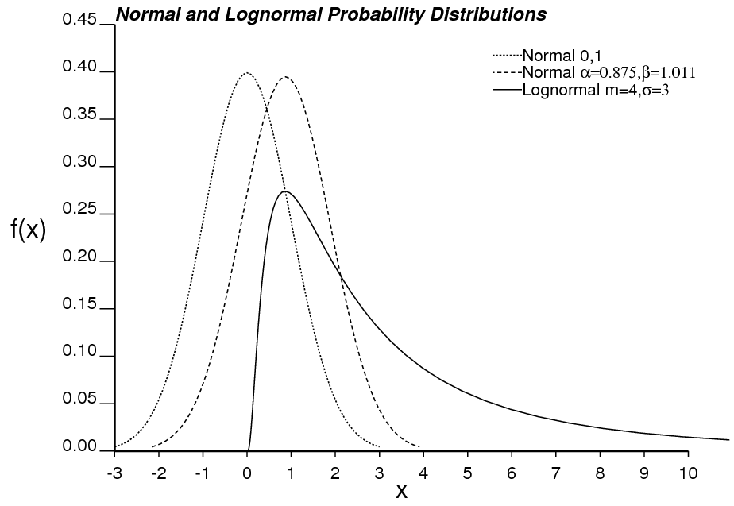
Figure 1: Standard normal distribution for Y(u), converted to a non-standard normal distribution X(u), and the corresponding lognormal distribution, Z(u).

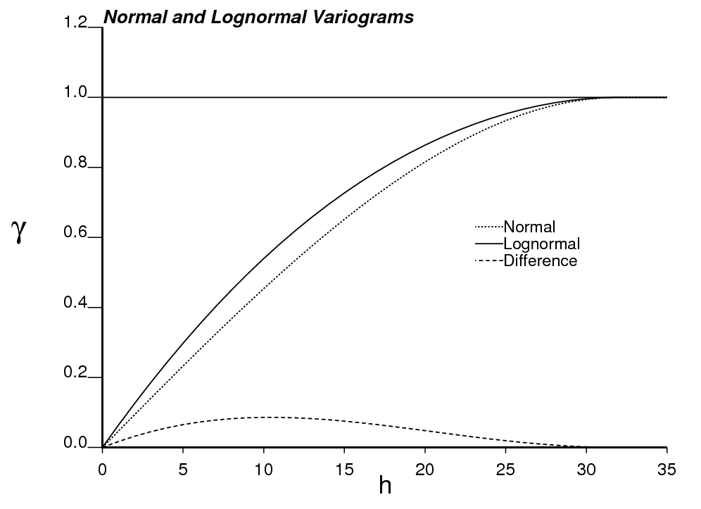
Figure 2: The Gaussian variogram model is spherical with no nugget effect and a range of 32. The corresponding variogram of the lognormal variable is shown with the difference between the two functions. Note that this variogram was used to generate the unconditional model for a subsequent example.
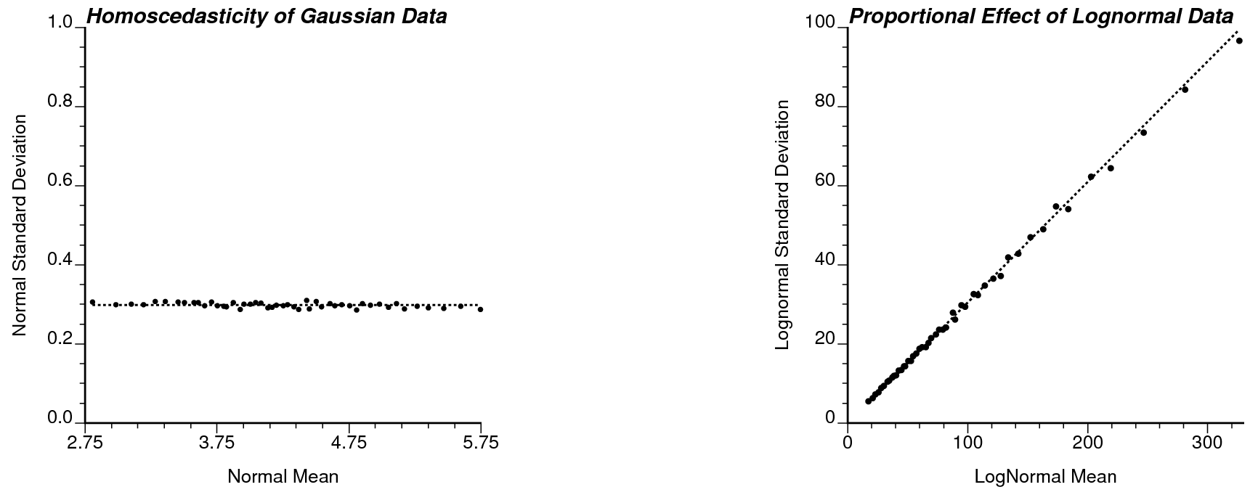
Figure 3: Scatterplots of Gaussian data showing the variance is homoscedastic (left) and lognormal data displaying the proportional effect (right).

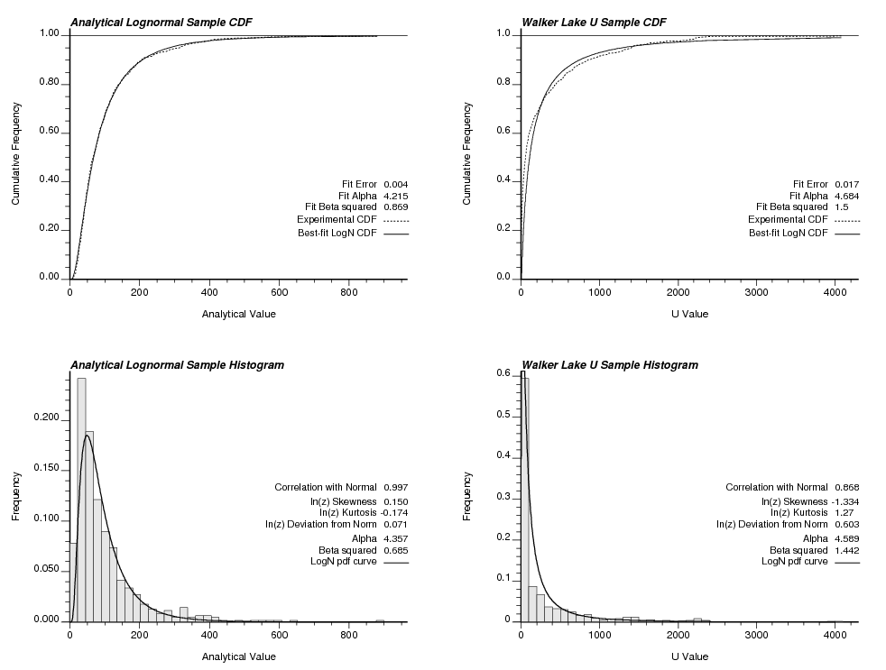
Figure 4: Lognormality Test Comparison for synthetic data (left) and Walker Lake U variable (right).
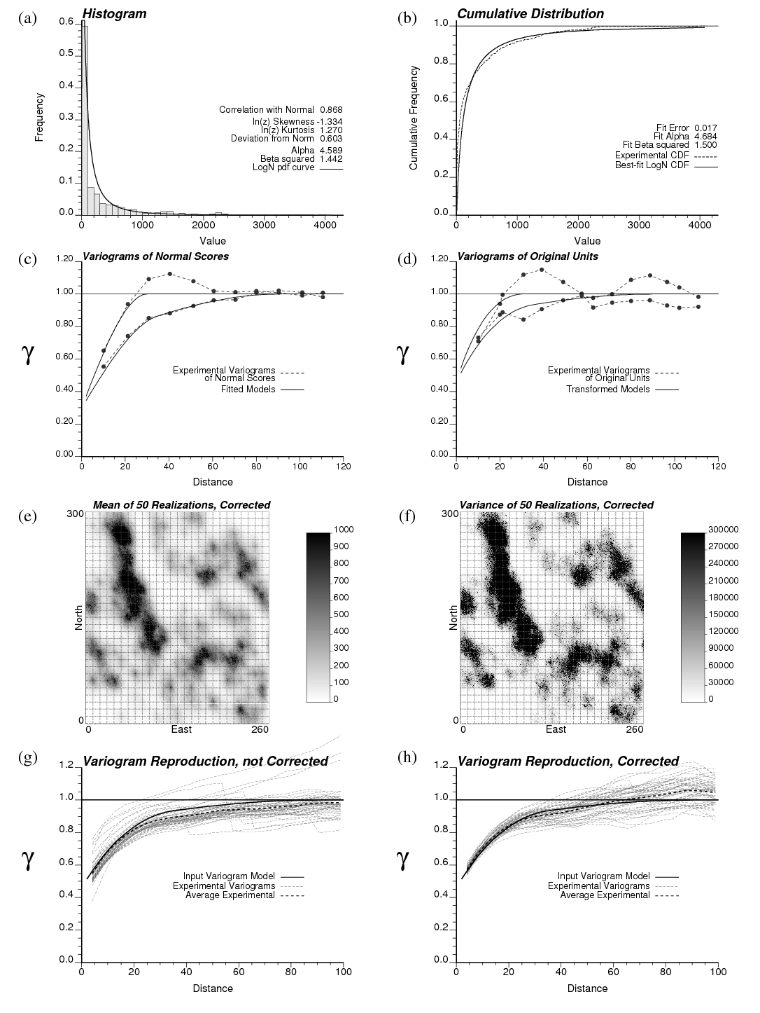Figure 5: Walker Lake Variable U: (a) Original data histogram, (b) Original cumulative distribution, (c) Normal scores variogram, (d) Original data variogram, (e) e-type estimate based on 50 simulated realizations, (f) conditional variance based on 50 simulated realizations, (g) variogram reproduction after DSS with no correction for the homoscedastic local variance, and (h) variogram reproduction from DSS with variance correction applied.
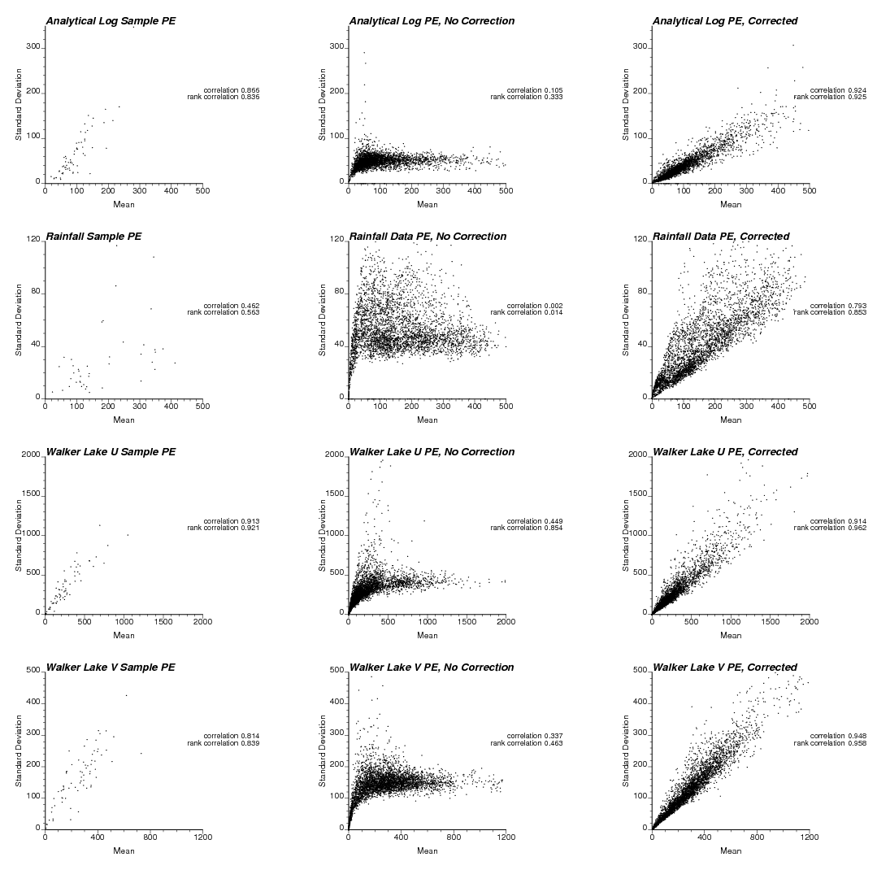
Figure 6: Proportional effect reproduction based on original data (left) simulation with no variance correction (middle) and with a correction (right) for the four data sets explored: synthetic data (top row), SIC rainfall data (second row), Walker Lake U (third row) and V (last row).

